**GPA and Undergraduate Classification at The University of Texas at El Paso**

Jesus Marquez

May 5. 2022

**Abstract**

Quantifying experience can be challenging, yet the environment of University/College may allow us to have it quantify. This can lead us to hypothesize that GPA is significantly different among classifications of undergraduate students at the University of Texas at El Paso. This was tested by creating an experiment that consists of a survey that is targeted to of undergraduate students at the University of Texas at El Paso. The results show us that we did not have enough evidence to support our hypothesis as the statistical analysis results where weak, *F*(2, 94) = .581, *p* = .629. Further investigation is needed and can be improved by implementing several steps to make the experiment better.

**Introduction**

Experience is always seen as a positive attribute to have. It can often be perceived to make someone a better employee, student, and person overall. The way experience is gain is to complete a task and remember the information that what was learn in completing that task. Then that experience is used to better improve the following similar task. Experience is an important factor in life that let us improve and become better as times goes by. Knowing if experience truly makes a difference in a quantitative way may increase our understanding of it.

The problem is that it can be hard to quantify how experience someone is. Yet there may be a way to illustrate someone’s experience as a student. Students are given grades base on their performance as students and those grades are consolidated into their GPA. A University/College setting is the perfect opportunity to understand the concept of experience. As a student completes a semester, they gain experience that can help them perform better on their next semester. If experience truly makes someone a better student, then we would see a quantifiable difference between a student with experience and one with no experience. It is important that our target population be that of a University/College.

Knowing that GPA is consider a recognize measurement of how well a student is doing in his academic/career advancement in college. These makes students and faculty put a heavy weight on GPA. Students are then incentive to maximize their experience to obtain a better GPA. As this measurement is already established and has been in use for decades, we would use it to help us answer our question. University/Colleges use a categorical system to determine the advancement of a student’s career as they attend said University/College. The more a student advance in their career it can be assume that they have more experience. We hypothesize that GPA is significantly different among classifications of undergraduate students at the University of Texas at El Paso. To prove this, we need to develop methods to conduct an experiment.

**Methods**

To answer our question an experiment was designed. To complete our experiment, we needed to know our study design, population/sample, and data collection. The study design that was chosen was that of a Correlational Sample Study (CSS). We are using CSS because we want to know the relationship between two variables of a population. Sampling this population would allow us to infer a conclusion about the population with a small number of data points. The variables that we are examining are a quantitative dependent variable (QDV) which is GPA and categorical independent variable (CIV) which is Classification. Our CIV has the levels of Freshman, Sophomore, Junior, and Senior. Knowing our population is important making it part of our experimental design.

To better answer our question; we decided that our target population would be undergraduate students at the University of Texas at El Paso (UTEP). This population was chosen because they are the population of interest in our question, and due to been easily accessible to survey. Undergraduate students at UTEP can be dived into four levels of Freshman, Sophomore, Junior, and Senior. Our sample was a simple random sample (SRS) that was taken form the target population. This SRS was achieved with several techniques that involve the location where the survey was distributed. (More details discussed later) Data collection allows us to get data to answer our question making it an important aspect of our experiment.

A survey was utilized to collect data, this survey was hosted on Google forms. The form consists of 5 questions; some of the questions are utilized to know if participants are eligible to take part of the experiment. Other questions are utilized as data collection regarding the participants classification and their GPA. (For a more detailed view of the survey look at Link A) To achieve an SRS survey distribution was done in two ways; by distributing psychical QR that takes participants to take the survey and by sharing the survey link on unofficial UTEP online forums (Discord). The QR codes where distributed in front of the UTEP library at midday and were given randomly to induvial passing by. This methodology allows us to collect data to further answer our question by analyzing this data.

**Results**

Once the data was collected it was used to come to a conclusion that would help us answer our question. This conclusion was done by cleaning the data, choosing a statistical method, and analyzing the results from the statistical method. When the survey period ended, we took a preliminary look at the data and found out not all participants answers where eligible to be use on the study. (Raw data available at Link B) The total of responses was 109; out of the responses 2 did not consent for their data to be use, 9 where not undergraduate students, and 2 responses where not complete. A total of 13 responses where not use leaving us with a total of 93 eligible response to use. Out of the eligible responses our CIV had the following sample size: Freshman (n = 14), Sophomore (n = 10), Junior (n = 28), and Senior (n = 44). To know if our data is robust enough for the statistical method we are using, we calculated the standard deviation for each level: Freshman (SD = .419), Sophomore (SD = .404), Junior (SD = .597), and Senior (SD = .447). For a better look at the descriptive statistics of our clean data look for Table 1. (Clean data available at Link C) With a better understanding of our data, we move to select the statistical method that we are using.

The statistical method that was chosen to analyze our data was a One-Way Analysis of Variance (ANOVA). This was done because the way our experiment was set up and the capabilities that a One-Way ANOVA has. The way our experiment was design it has a CIV and a QDV. The capabilities of a One-Way ANOVA are that it can gives a look at the difference in means on our CIV levels. Giving us an idea if our CIV levels have an effect on our QDV. The data must meet certain conditions to be able to use a One-Way ANOVA. These are independence on our CIV levels, our CIV levels population need to have normal distribution with an unknown mean, and CIV levels population need to have the same standard deviation. Our data meets the condition of independence as the levels of our CIV do not interact or interfere with one another. The normal distribution condition is met by our data because One-Way ANOVA is not particularly sensitive to differences in Normality. For this we assume that data meets the conditions. In One-way ANOVA standard deviation conditions are often assumed to be the same across all populations, therefore our data meeting the condition. The significance level for this test has been set to *p* < .05. One issue that our data may have is that our sample size is not equal among the levels of our CIV. This can present a problem with the assumption that where made. Still, we continue to conduct our analysis because we conducted a pre analysis observation of the standard deviation of each CIV level. This enables us to ensure a small amount of variance among each CIV level standard deviation. Taking all this in consideration we follow to our analysis.

Our analysis would allow us to know if we can reject our null hypothesis supporting our alternative hypothesis. The null hypothesis can be determined to be as follows; GPA is significantly not different among all undergraduate classifications at The University of Texas at El Paso. Then the alternative hypothesis is GPA is significantly different among all undergraduate classifications at The University of Texas at El Paso. These hypotheses are two tails as we are not predicting a positive or negative affect. The One-Way ANOVA was run in the statical software R. (For the R file access use Link D) This software was use as it is the one researcher are comfortable with using. The results of the test can be found on Table 2. The results lead us to conclude that GPA is significantly not different among all undergraduate classifications at The University of Texas at El Paso, *F*(2, 94) = .581, *p* = .629. This indicates that we fail to reject our null hypothesis making us not have enough evidence to support our alternative hypothesis. Even though our One-Way ANOVA results did not support our hypothesis we can still take a lot from the experiment.

**Discussion**

Having the results of the analysis with can discuss what this means for our experiment in terms of is effect and how future experiments may differ and be improved. Knowing that our data does not support our hypothesis that GPA is significantly different among classifications of undergraduate students at the University of Texas at El Paso. As there was no significant difference among the CIV levels means. We may be able to determine that experience does not make someone a better student. Even if the experiment did not support our claims, it gave us an opportunity to investigate some statistical features of the students attending the University of Texas at El Paso. This is not a conclusive experiment as there can be factors that affected our experiments that can improve in the future.

One of the most notable problems that we ran on the experiment was the unbalance on the sample size among the CIV levels. This may have not caused the statistical method to have a different result as the One-Way ANOVA has a small amount of sensitivity to this issue. Still there may be a lingering difference that can make a change. One way to improve the overall experiment and this issue is by having more participants be on the experiment allowing for more robust data. If unbalance on sample size among CIV levels continue even after the prescribe improvements additional steps can be taken. Overall, the experiment was a success as it allow for a learning experience in experiment design, statistical analysis, and data collection.

References:

Tables and Figures:

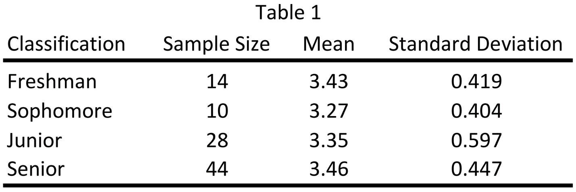

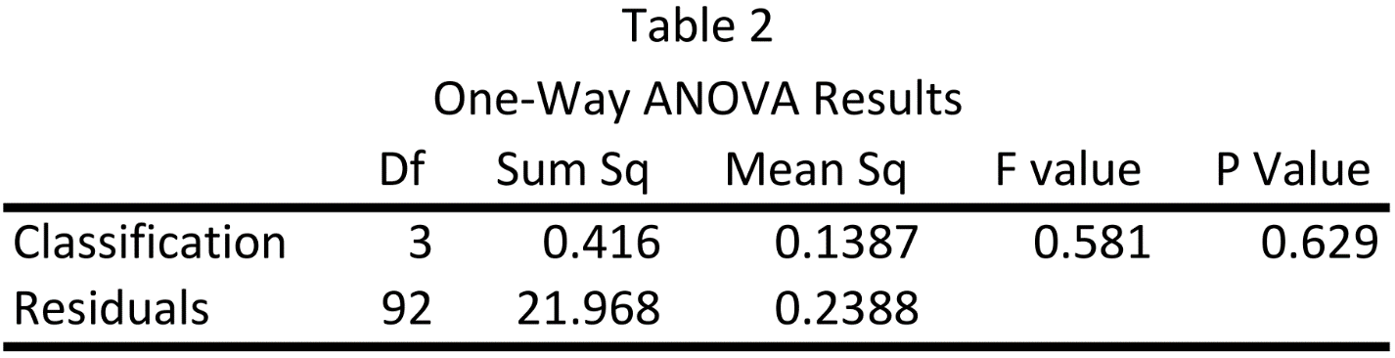

Appendix:

Link A: <https://minersutep-my.sharepoint.com/:b:/g/personal/jjmarquezgarcia_miners_utep_edu/EeGb3NCCp5pIlWkYd7tNrtIBRvM3m9HFAhP8W4cUaohSLw?e=C0ICSF>

Link B: <https://minersutep-my.sharepoint.com/:x:/g/personal/jjmarquezgarcia_miners_utep_edu/Ecmkotu2hktJhRU2SKMgAcUB1wVg-81VKzzsHeBr0-qsGQ?e=b5K5hs>

Link C: <https://minersutep-my.sharepoint.com/:x:/g/personal/jjmarquezgarcia_miners_utep_edu/EdVvLvw_lnBGt_RutEXb3YwB0uU8MD6-cxJBclCP284mvg?e=liyeLj>

Link D: <https://minersutep-my.sharepoint.com/:u:/g/personal/jjmarquezgarcia_miners_utep_edu/Edu9Y_UVQUJMmFkYEgSCqA8BPQYBbRWnoT6qLzXC48SFXw?e=J8bPg6>